1
Structured Abstract and Keywords
Hosam Elsayed Farag MD, Mahmoud Abouzied MD.

Corresponding author:
Mahmoud Shaapan Abouzied, M.D.

Benha University Faculty of Medicine Benha, Egypt.

Tel: 00201001196707
Abouziedmz83@gmail.com
Hosam Elsayed Farag
Orthopedic Department, Faculty of Medicine, Benha University, Benha, Egypt Correspondence to Hosam Elsayed Farag, MD, Lecturer of orthopedic surgery. Orthopedic department, Benha University El-Shaheed Farid Nada Street, Banha, Qalyubia, Egypt,
Tel: 01002953963E-mail: hosamfaragortho@gmail.com
Declaration of conflicting interests
There is none to be declared.
Funding
There is none to be declared.
Number of pages: 17
Number of abstract words: 223
Number of article words: 2802
This prospective study was conducted following the approval number 036/2019 of the Institutional Ethics Committee of Benha university including ethical committee approval of Benha orthopedic department, ethical committee approval of Benha faculty of medicine and ethical committee approval of Benha university.

Abstract
Background: Controversy surrounds the treatment of a mallet finger caused by an intra-articular fracture of the distal phalanx encompassing at least one-third of the articular surface. This study evaluated the efficacy of Delta wire pinning for mallet finger fractures.
Methods: 11patients (6 males &5 females) with a bony mallet finger treated by Delta wire pinning in the period between 2017 to 2019 years.
Results: The follow up had a mean value of 18.5 months, and the average time of union was 32 days. In all cases, the fracture healed by solid bony union without joint subluxation. VAS score has a mean value of 0.2 and the mean quick DASH score was11.7. Active flexion of the distal intrephalangeal joint had a mean value of 81.2̊ and the average extensor lag was 1.4̊There was one patient with superficial pin site infection with no pin migration, non-union, tender dorsal prominence, osteomyelitis nor skin sloughs. According to Crawford classification 72.5% of patients had excellent results, 18.5% had good results, 9% had fair results and 0% had poor results. Conclusion: Early results of Delta wire pinning have shown to achieve early full active flexion of DIPJ with strong compression force on the fracture fragment continually with early return to occupation.
Key words: Mallet finger, Delta wire, distal phalanx, Bony fragment.
Level of the study: level IV case series.

Manuscript (No
Introduction
The mallet finger is sometimes referred to as a drop finger and a baseball finger [1, 2]. This condition is characterized by the failure of the distal interphalangeal (DIP) joint's extensor mechanism. Any substantial flexion of a fully extended DIP joint may cause separation of the terminal extensor mechanism or avulsion fracture of the distal phalanx base [3, 4]. Long, ring, and little fingers on the dominant hand are the most typically afflicted [1] digits. Lesions are prevalent in men aged 20 to 40 and women aged 50 and older. Doyle's [2] classification scheme divides mallet injuries into four separate categories (Table 1). Mallet fractures characterize all three categories of Type IV lesions.
Diverse types of mallet fractures are still the subject of controversy [5]. Continuous hard aluminum splinting, Plaster-casting prefabricated splints, and customized orthoses are the conservative therapy choices for displaced mallet fractures [6, 7]. Numerous complications, including joint stiffness, necrosis, skin maceration, extension loss, and hyperextension deformity, have been seen with various treatment methods [8]. Inadequate patient compliance can worsen extensor lag more than 10°, early osteoarthritic changes and Swan neck deformity [1, 3].
Several open and percutaneous surgical procedures for mallet fractures have been documented, including:
- Fixation with Kirschner (K) wire under direct vision [9].
- Interosseous wiring [10].
- Tension wire fixation [11].
- Extension block fixation and its modifications [12-16].
- Fixations using screws or miniscrews [17-19].
- Internal suturing [20].
- Pull-out wire suturing [21-23].
- External fixation [24].
- The umbrella handle' technique [25].
- Hook-plate fixation [26].
- The pulp traction technique [27].
- Delta
() – The wire approach enables early joint mobility and continual, powerful fracture fragment compression. However, few papers explore the method's clinical repercussions.
The current study presented the clinical outcome of Delta wire in management of bony mallet in which using this technique to be simple, rapid, effective technique regarding; reduction, healing and early range of motion.

Patients and Methods
Between 2017 and 2019, 11 patients with a mallet fracture were treated by Delta wire Technique. This study was conducted following the approval number 036/2019 of the Institutional Ethics Committee of our university. Informed consent was taken for every patient included in the study. The study is a case series study.
Inclusion criteria were closed, displaced mallet fracture with minimum fracture fragment on radiograph that was greater than 1/3 of the articular surface or a fracture associated with DIP joint subluxation. There were 6 men and 5 women. Patients had a mean age value of 26.8 years and the average delay after injury was 5.6 days. Six patients required surgery within one week after injury, whereas five patients received surgery between the first and second week. There were four ring fingers, two index fingers, and five tiny fingers involved. There were seventeen dominant hand injuries. The majority of injuries happened during sporting engagement.
A true lateral radiograph of the injured digit is employed to detect the distal phalanx's size, displacement, and volar subluxation. On average, 40.5% of the articular surface was compromised by fractures (range, 33%-60%). Four fractures (19%) were related with distal phalanx volar subluxation. Patients were followed up with a physical examination and radiographs every two weeks. On radiographs, it was established that the fracture union was a nontender DIP joint with a bridging trabaculate.
Functional outcomes were determined by using the Crawford criteria (1984) (table 2).

Operative technique:-
The procedure was performed on every patient using digital block anesthesia and C-arm image intensifier control. In 8 cases, 1.4-mm (0.045-inch) K-wires were employed, but in 3 patients with tiny hands, 0.9-mm (0.035-inch) K-wires were used.
For reduction, small K-wire (0.8 mm) was inserted through 18G needle and a hook is made then the K-wire was advanced with the counter-force (fig1). The K-wire was cut at distance of about 2.0 cm from fingertip and another hook was done. The thicker wire was then inserted along the long axis of distal phalanx intramedullary. Another hook was made and both hooks are attached together. Plaster was applied over them to prevent further injury to the skin (fig2).

Post-operation follow up:-

The patient was told to keep the injured finger dry, and proper pin care was administered. Patients were followed up approximately 2, 4, 6th, 8th weeks post operatively. Radiographic and clinical examinations were undertaken based on the Doyle and Crawford criteria (Table 1, II).
The following were recorded at the 8th week postoperatively; active flexion of DIPJ, visual analogue score (VAS) for pain, disability of arm, extension lag, shoulder and hand (DASH) score, deformity or complication presence. They were then rated according to Crawford criteria, excellent, good, fair or poor [33]. Figure 3 demonstrates radiographs and range of motion at 3 months postoperative visit of one of the patients.

Results:
Average follow-up duration was 18.5 months (range, 9-26 months). 32 days was the average time to fracture union based on bridging trabeculae on radiographs and a nontender fracture site (range, 28-42 days). At the time of the follow-up examination, radiographs of all instances revealed a firm osseous union. None of these digits had chronic distal phalanx subluxation. The joint surface was congruous and satisfactory in all but one patient (9%) had a step-off, the result in this digit was good. Only one patient (9%) had pain that was graded as minimal; (VAS) mean 0.2 and rang 0-1. Quick DASH scale mean 11.7 and range 7.8-16.1. The average active flexion of the distal interphalangeal joint was 81.2° (range 65° to 90°) and the average extensor lag was 1.4° (range, 0°- 10°).
There was one patient (9%) with superficial pin-site infection that resolved with oral antibiotics. There was no pin migration, non-unions, osteomyelitis, tender dorsal prominences, or skin sloughs. (Table 3)
According to Crawford classification, 72.5% of patients (8 out of 11) had excellent results, 18.5 (2 out of 11) had good results, 9% had fair results, and none had poor results.

Discussion
Regarding the treatment strategy for the various subtypes of mallet fractures, there was no consensus. Volar subluxation of the distal phalanx is possible when the fracture encompasses at least one-third of the articular surface, anatomical reduction by closed manipulation and external splinting are typically difficult, and fracture malunion affecting joint congruence is likely (28). Conservative treatment of volar subluxation of the distal phalanx with large fracture fragments (more than 50% articular surface involvement) (29) may result in aesthetic deformity as painful dorsal prominences, skin slough, and degenerative arthritis, which frequently causes pain and restricted mobility (7, 28). For nonsurgical therapy to be more effective, close observation is necessary.
Additionally, if the fracture fragment exceeds one-third of the joint surface, if the distal interphalangeal joint is subluxated and the displacement reaches three millimeters, or if conservative treatment has failed, surgical treatment is recommended (29, 30, 31,32). There is considerable controversy regarding open vs percutaneous treatment. The frequency of problems such as skin necrosis, nail deformity, infection, scarring, and joint stiffness increases after open surgical operations (15, 31).
Percutaneous surgical techniques were described to overcome the complications of open surgical reduction. Ischiguro et al. in 1988 introduced his procedure for percutaneous reduction through extension block technique by K- wire (12). Modifications on Ischiguro et al technique were emerged later on by Hormeister et al. (7) Lee YH et al. (13) Lee SK et al. (14) and Jorgsholm et al. (15).
Ishiguro recommended to freshen the fracture site by using an injection needle for neglected injuries more than 2 weeks. The overall complication rate for different extension block technique varies from 5-60% with extension lag up to 20 degrees.
Badia and Riano reported the results of immobilizing and avoiding fracture fragment dislocation in sixteen patients by inserting a curved K-wire into the fracture fragment and pulling with heavy pliers from the volar surface. The DIP joint exhibited two degrees of extension lag and seventy-five degrees of normal maximal flexion. Percutaneous umbrella handle reduction is a form of reduction. This approach, described by Roccjo et al. in 2006, comprises percutaneously inserting a K-wire from the dorsal or volar surface, stabilizing the fracture fragment, and leaving the distal interphalangeal joint unfettered for rapid postoperative mobility. 11 of the 48 patients who participated in the research were judged outstanding, 35 were deemed good, and 2 were deemed bad according to Crawford's criteria.
Yamanaka and Sasaki reported employing temporary extension block pinning by inserting one or two 1.2 mm K-wires into the bone fragment, and then withdrawing the extension block K-wires within 12 days postoperatively to permit active DIP range of motion. This early range of motion resulted in 1 degree of extension to 69 degrees of flexion, according to their findings (17).
For mallet fractures, Kronglage and Faust utilized two or three 6-8 mm miniscrews. On the patient's dorsum, a finger bump was noticed recently. Nonetheless, the issue was asymptomatic. The average motion range was between 6 degrees (extensor lag) and 70 degrees (flexion) (18).
Using this adjustment, the present experiment yielded comparable results to those of other writers. Delta wire pinning is an efficient, straightforward, and speedy procedure that may be performed under digital block anaesthetic. The method is technically straightforward, resulting in quick fracture union, a broad range of motion, and few problems. It permits reduction of anatomic fractures without requiring an incision. If anatomic reduction cannot be achieved without surgery, mallet fractures accompanied by joint subluxation and severe articular fractures must be treated surgically.
In one case, we detected a slight infection of the pin tract, no nail ingrowth, and peeling skin. No individuals required revision or further surgery as a result of complications. In our series, the average range of motion was 1.4 degrees of extensor lag to 81.2% flexion. Our results are equivalent to those achieved by other efficient methods documented in scholarly literature. In our data collection, the median time between fracture and surgery was 4.1 days. Surgical intervention undoubtedly contributed to our procedure's success.
The limitations of our study is the limited number of patients included together with the study is not comparative with other surgical techniques. We encourage future randomized control studies to compare between different surgical techniques used for displaced bony mallet with included large number of patients.
Declaration of conflicting interests
None to be declared.
Funding
None to be declared.

CONCLUSION:
Early results of delta wire technique have shown to achieve early full active flexion of DIPJ with early return to occupation. The absence of transarticular k wire allows for immediate DIPJ motion which produces good active flexion.

References
1. Lamaris GA, Matthew MK. The Diagnosis and Management of
Mallet Finger Injuries. Vol. 12, Hand. 2017. p. 223–8.
2. Bachoura A, Ferikes AJ, Lubahn JD. A review of mallet finger
and jersey finger injuries in the athlete. Vol. 10, Current Reviews
in Musculoskeletal Medicine. 2017.
- Valdes K, Naughton N, Algar L: Conservative treatment of mallet finger: A systematic review. J Hand Ther. (2015) 28(3): 237-246.
- McMurtry J, Isaacs J: Extensor tendon injuries. Clin Sports Med (2015) 9: 34(1): 167-180.
- Lin JS, Samora JB: surgical and non-surgical management of Mallet Finger. A systematic review. J Hand Surg Am (2018); 43(2):146-163.e 2.
- Lester B, Jeong G. K., Perry D. and Spero L.: A simple effective splinting technique for the mallet finger. Am J Orthop (2000): 29: 202-206.
- Hofmeister E. P., Mazurek M. T., Shin A. Y et al: Extensions block pinning for large mallet fractures. J Hand (2003) Surg [Am]: 28: 453-459.
8. Ramponi DR, Hellier SD: mallet finger.
Advanced Emergency Nursing Journal (2019) vol 41, Lippincott Williams and Wilkins. p. 198-203.
- Hamas RS, Horrel ED, Pierret GP. Treatment of mallet finger due to intra-articular fracture of the distal phalanx. J Hand Surg Am (1978);3:361-3.
- Chiba G, Nakamura S, Kitahara H. Interosseous wiring method for the treatment of mallet finger with tiny fragment. The Journal of Japanese Society for Surgery of Hand (1992); 9:682-6.
- Jupiter JB, Shepard JE. Tension wire fixation of avulsion fracture in the hand. Clin Orthop Relat Res(2014):113-120.
- Santiago S, Juan J, Anissa B, et al. Review of acute traumatic closed mallet finger injuries in adults Arch Plast Surg.(2016)
- Lee YH, Kim JY, Chung MS, Baek GH, Gong HS, Lee SK. Two extension block Kirschner wire technique for mallet finger fractures. J Bone Joint Surg Br (2009); 91:1478-1481.
- Lee SK, Kim KJ, Yang DS, Moon KH, Choy WS. Modified extension-block K-wire fixation technique for the treatment of bony mallet finger. Orthopedics (2010); 33:728.
15. Jörgsholm P, Björkman A, Emmeluth C, Björkman-Burtscher IM. Extension block pinning of mallet fractures. Scand J Plast Reconstr Surg Hand Surg (2010); 44:54-8.
- Sakaue M, Sumimoto Y, Omori K, Yoshida M. Treatment of mallet finger using a micro screw. The Journal of Japanese Society for Surgery of Hand (1986); 3:538-41.
- Yamanaka K, Sasaki T. Treatment of mallet fractures using compression fixation pins. J Hand Surg Br (1999); 24:358-60.
- Kronlage SC, Faust D. Open reduction and screw fixation of mallet fractures. J Hand Surg Br (2004); 29:135-8.
- Jiang B, Wang P, Zhang Y, et al Modification of the internal suture technique for mallet finger. Medicine (Baltimore) (2015); 94(6):e536.
- Zhang X, Meng H, Shao X, Wen S, Zhu H, Mi X. Pull-out wire fixation for acute mallet finger fractures with k-wire stabilization of the distal interphalangeal joint. J Hand Surg Am (2010); 35:1849-1864.
- Lee SK, Kim HJ, Lee KW, Kim KJ, Choy WS. Modified pull
out wire suture technique for the treatır.ert of chronic bony mallet finger. Ann Plast Surg (2010); 65:466-70.
22. Cheon SJ, Lim JM, Cha SH. Treatment of bony mallet finger using a modified pull-out wire suture technique. J Hand Surg Eur Vol (2011); 36:247-9.
- Kaleli T, Ozturk C, Ersozlu S.External fixation for surgical treatment of a mallet finger. J Hand Surg Br (2003); 28:228-30.
- Rocchi L, Genitiempo M, Fanfani F. Percutaneous fixation of mallet fractures by the "umbrella handle" technique. J Hand Surg Br (2006); 31:407-12.
- Acar MA, Guzel Y, Gulec A, et al. Clinical comparison of hook plate versus extension block pinning for bony mallet finger: a retrospective comparison study. J Hand Surg Eur (2015) Vol. 40:832-839.
- Kang HJ, Lee SK. Open accurate reduction for irreducible mallet fractures through a new pulp traction technique with primary tendon repair. J Plast Surg Hand Surg (2011); 46:438-43.
- Miranda BH, Murugesan L, Grobbelaar AO, et al: PBNR: Percutaneous blunt needle reduction of bony mallet injuries. Tech Hand Up Extrem Surg. (2015)19:81-83.

- Zengbeng L, Kai M, Dong H: Treatment of mallet finger deformity with a modified palmaris longus tendon graft through a bone tunnel. Int J Burns Trauma (2018) 5 ;( 2):34-39.
- Kim JK, Kim DJ. The risk factors associated with subluxation of the distal interphalangeal joint in mallet fracture. J Hand Surg Eur (2015) Vol 40: 63-67. 1985; 76; 580-85.
- Badia A, Riano F. A simple fixation method for unstable bony mallet finger. J Hand Surg Am (2004); 29:1051-5.
- King HJ, Shin SJ, Kang ES. Complications of operative treatment for mallet fractures of the distal phalanx. J Hand Surg Br (2001); 26:28-31.
- Green DP, Butler TE. Fractures and dislocations in the hand. In:
Rockwood CA Jr, Green DP, editors. Fractures in adults. Vol. 1.
Philadelphia: JB Lippincott; (1996). p. 616-22.
- Saito K, Kihara H: A randomized controlled trial of the effect of 2-step orthosis treatment of mallet finger of tendinous origin.
J Hand Ther. (2016) : 29(4): 433- 439.

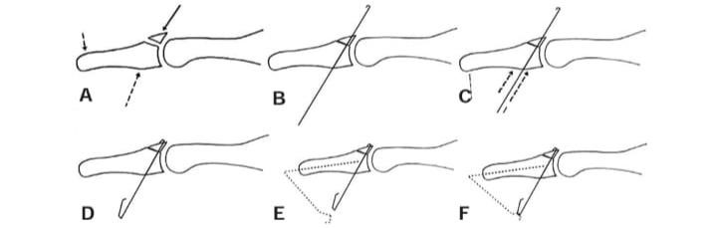

Figure (1) diagram showing surgical steps: ( A) correct reduction :slight flexion with suspension, (B) insert K-wire(0.8 mm) and make a hook,(C) advance K-wire with the counter- force, (D) cut the K-wire at distal 2.0 cm long or less and make another hook, (E) insert another K-wire(1.0 mm) along the long axis of distal phalanx intramedullary. Make an acute angle and another hook leaving 5 mm of distance from the previous K-wire, (F) Hang the 2 hooks and apply plaster over them to prevent further injury to skin.

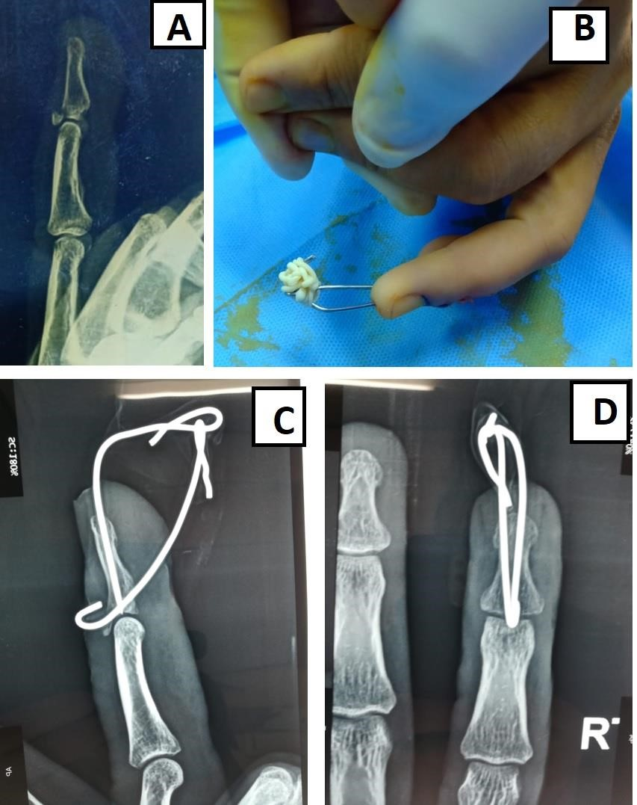
Figure 2: (A)pre-operative lateral x-ray shows bony mallet finger on ring finger (B) Delta wire construct with DIPJ in full extension, (C) and (D) Lateral, postero-anterior radiographs showing Delta wire construct.

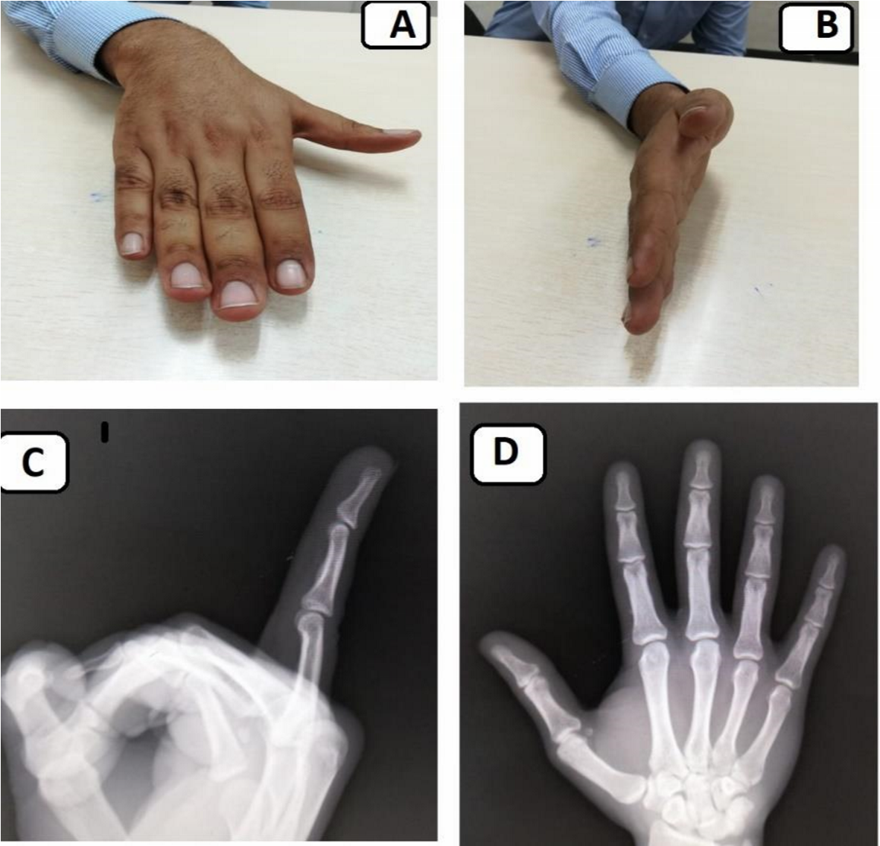

Fig (3): after removal of Delta wire construct 2 months post-operatively follow-up showed excellent movements (A and B) and radiography Lateral, post-anterior views showed well union (C and D).

Table(1):
Doyle's Classification of Mallet Finger Injuries (2)
Type | Description
I | Closed injury, with or without small dorsal avulsion fracture.
II | Open injury (laceration).
III | Open injury (deep abrasion involving skin and tendon substance).
IV | Mallet fracture:  - Distal phalanx physeal injury (pediatric).  - Fracture fragment involving 20% to 50% of articular surface (adult).  - Fracture fragment >50% of articular surface (adult).

Table (2):
Crawford Classification (33)
Classification | Extension Loss | Flexion | Pain
Excellent | None | Full | None
Good | 0° to 10° | Full | None
Fair | 10° to 25° | Any loss of flexion | None
Poor | > 25° | Any loss of flexion | Persistent pain

Table (3): Demographic DATA, Preoperative and Postoperative Results
No |  | Patients |  | Pre-operative Data |  | Post-operative
 | Age | Dominant  Hand | Finger | Fragment  Size% | Subluxation | Extensor  Lag | Active Flexion
1 | 33 | - | Small | 33 | - | 0° | 75°
2 | 25 | + | Ring | 40 | + | 0° | 80°
3 | 20 | + | Ring | 35 | - | 0° | 90°
4 | 22 | + | Small | 40 | - | 0° | 83°
5 | 24 | - | Small | 40 | - | 0° | 85°
6 | 30 | + | Ring | 35 | - | 0° | 90°
7 | 24 | + | Middle | 33 | + | 5° | 70°
8 | 28 | - | Middle | 40 | - | 5° | 75°
9 | 22 | - | Small | 40 | - | 0° | 85°
10 | 25 | + | Ring | 33 | - | 0° | 80°
11 | 42 | + | Ring | 40 | - | 0° | 80°

